Hazards
Tools/Equipment
Employee Group(s)

Required PPE:
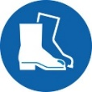  Safety Shoes |   Ear Protection |   Eye Protection |   Gloves | 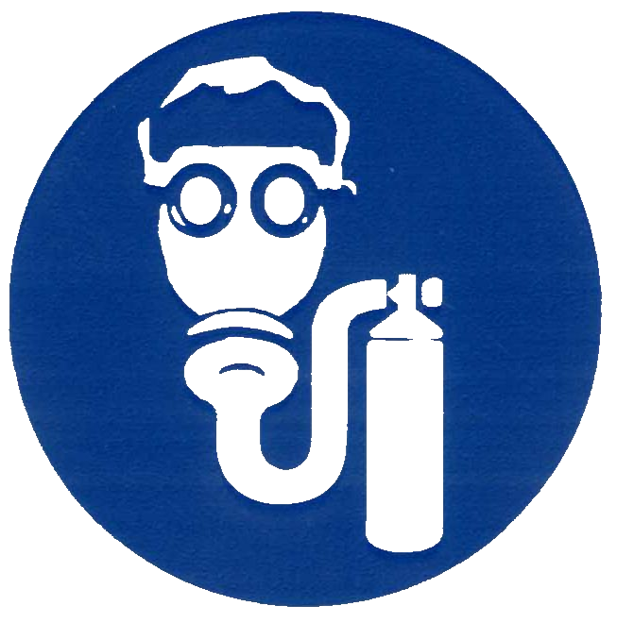  Respirator |   Face Shield |   Splash Glasses | 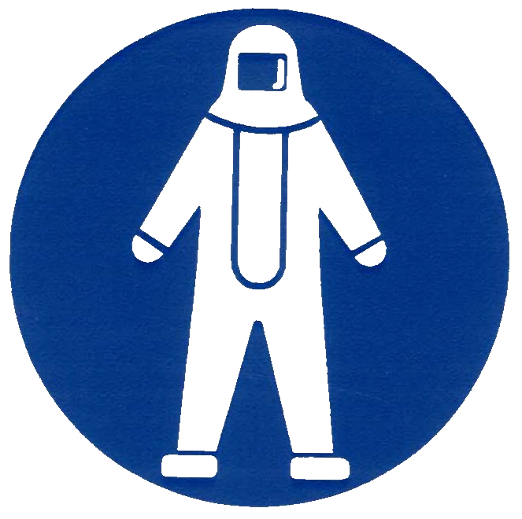  Protective Suit |   Hard Hat | 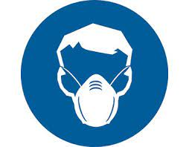  Dust  Mask

SAFE WORK PRACTICES
- Do not perform the procedure or operate the equipment until you have been appropriately trained and authorized to do so by your supervisor.
- Inspect required personal protective equipment (PPE) and replace if required.
- Do not wear loose-fitting clothing, dangling jewelry, etc.

PROCEDURE

