Disability, Access, Equity & Education: Creating Welcoming Communities
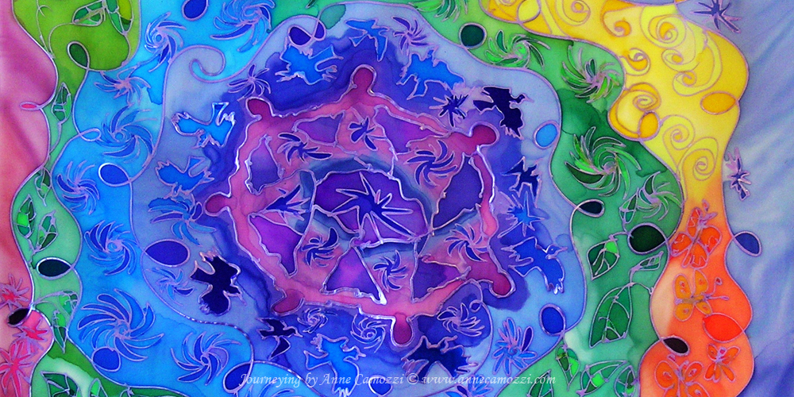
Program at a Glance

Monday, August 26th, 2019 at St.F.X. University
10:00 am to 10:15 am  | Coffee and Light Refreshments
10:15 am to 10:30 am | Welcome and Introductions
10:30 am to 10:45 am  | Land Acknowledgement
10:45 am to 12:45 pm   | Opening Plenary
12:45 pm to 1:45 pm  | Lunch
1:45 pm to 2:45 pm | Concurrent Session 1  - Workshop  - Oral Presentations - Reimagining Inclusion in Classrooms & Communities  - Oral Presentations - Accessible Environments  - Circle Conversation – Disability & Disruption in Higher Education
2:45 pm to 3:00 pm  | Refreshment Break
3:00 pm to 4:30 pm | World Café:  Creating and Sustaining Equitable Communities, Classrooms and Workplaces
4:30 pm to 6:00 pm   | Break
6:00 pm to 8:00 pm | Dinner - Doors open at 5:30 pm  Social Enterprise and Convention Centre Located at 75 St. Ninian Street, Antigonish  Performance by the Park Bench Players at 6:30 pm

Tuesday, August 27th, 2019 at St.F.X. University
8:45 am to 9:00 am | Coffee and Light Refreshments
9:00 am to 9:15 am | Welcome and Reflections on Themes from Day 1
9:15 am to 11:00 am | Opening Plenary
11:00 am to 11:15 am | Refreshments Break
11:15 am to 12:30 pm | Concurrent Session 2  - Panel: Disability and Equity at St.F.X.  - Oral Presentations: Welcoming Classrooms, Communities and Relations to Bodies
12:30 pm to 1:30 pm | Lunch
1:30 pm to 3:00 pm | Concurrent Session 3  - Pedagogical Workshop: Access as Pedagogy: Exploring Collective Practices of Teaching and Learning  - Community Circle Conversation: Equitable Community Relations
3:00 pm to 3:15 pm | Break
3:15 pm to 4:15 pm | University-Community Collaboration Plenary
4:15 pm to 4:30 pm   | Closing Reflections and Discussions of Next Steps
4:30 pm   | Wrap-Up and Adjournment

