How to Request Alternate Format Textbooks
- Go to the ClockWork Home Page by clicking this link https://tramblecentre.stfx.ca/custom/misc/home.aspx
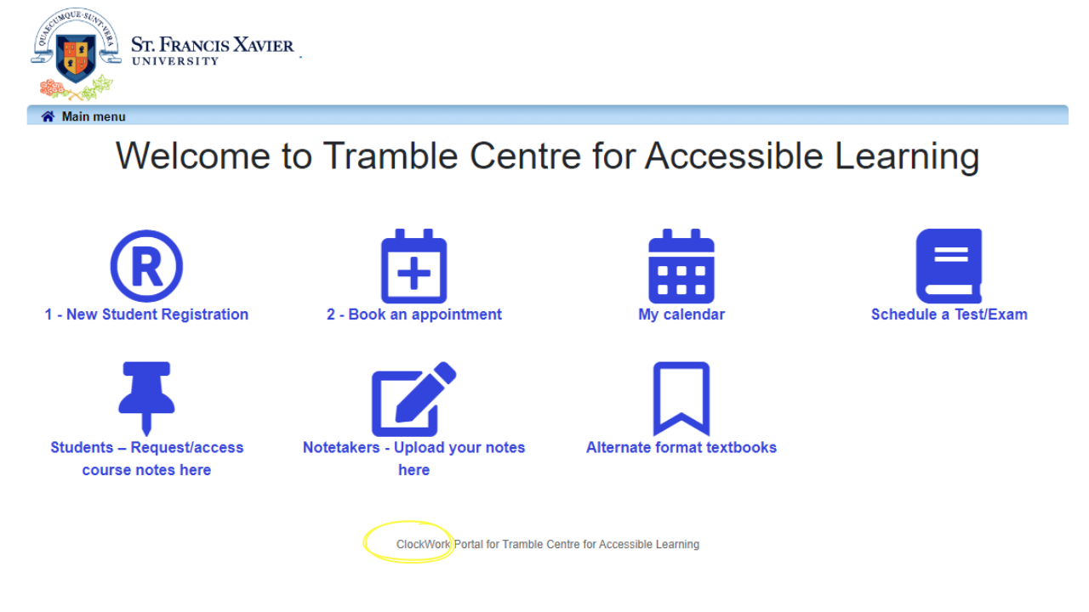
- Click the Alternate format textbooks button. Once you click this button, you will be prompted to sign into the system.
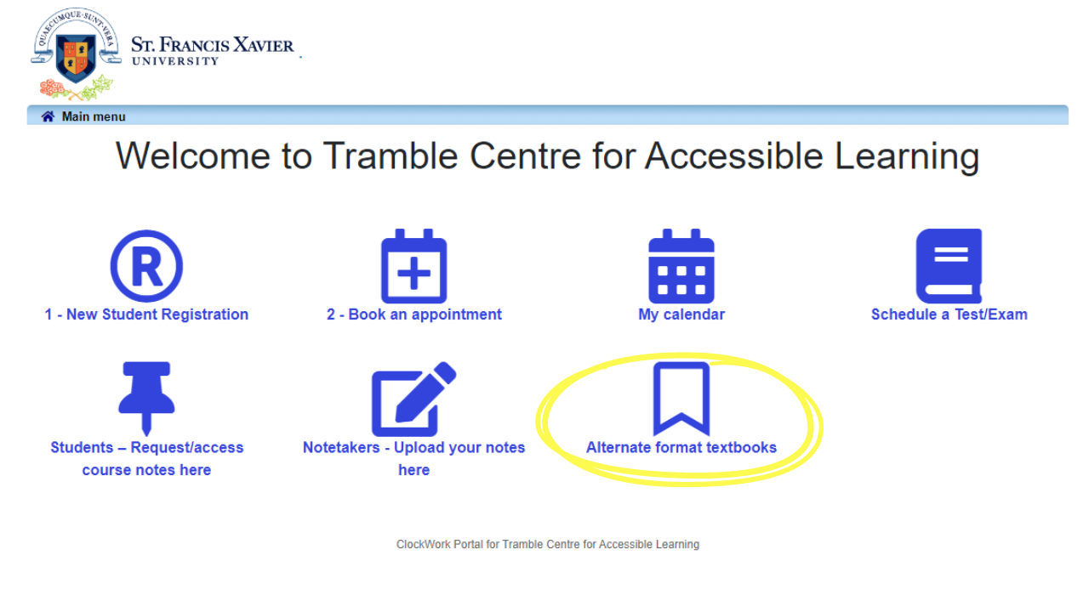

- Sign-In
- Once signed in, click the Alternate format textbooks button again.
- Read and sign the Copyright Agreement Form.
- Click on New Request or Create a New Request.
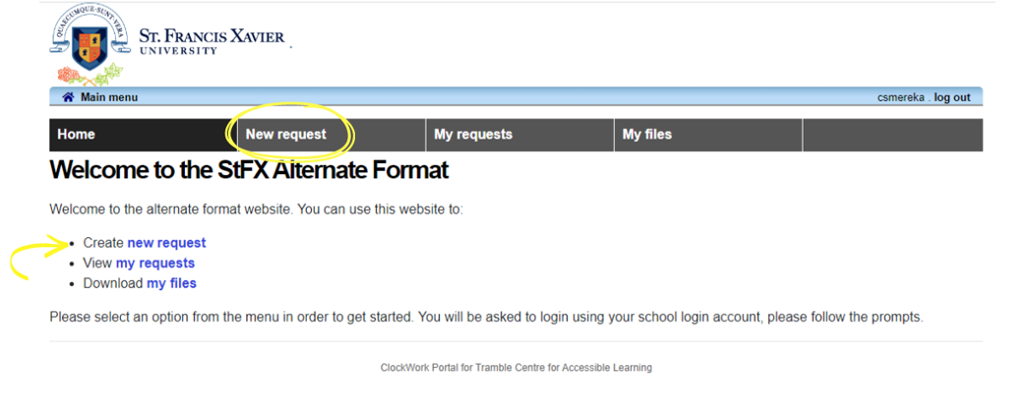

- Click the Searching for Books button.
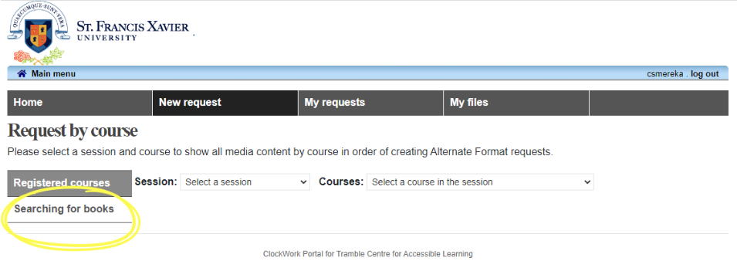
- Search for the book by Title or the ISBN, then click the Search Icon.
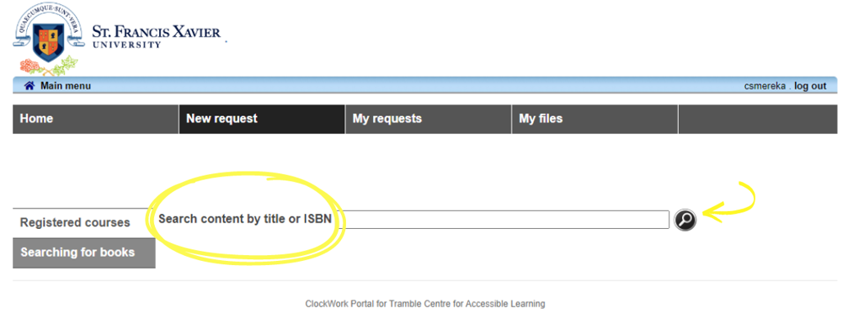
- Review the list of books that appear. Click the Plus icon when you find the textbook you are looking for. *Note – The ISBN might be different if you purchased an online book or a loose sheet package from the bookstore. See image on next page.

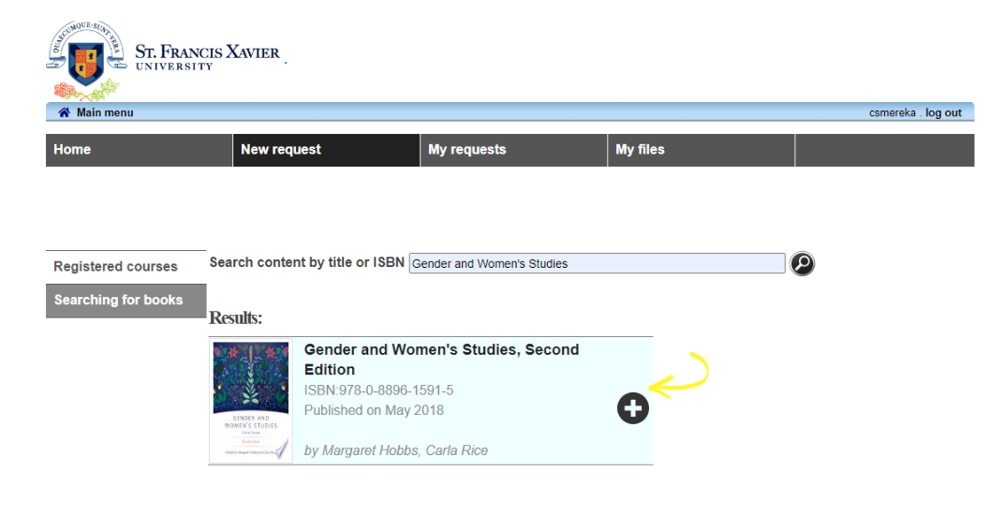
10. Click the Shopping Cart to add your request to your cart.
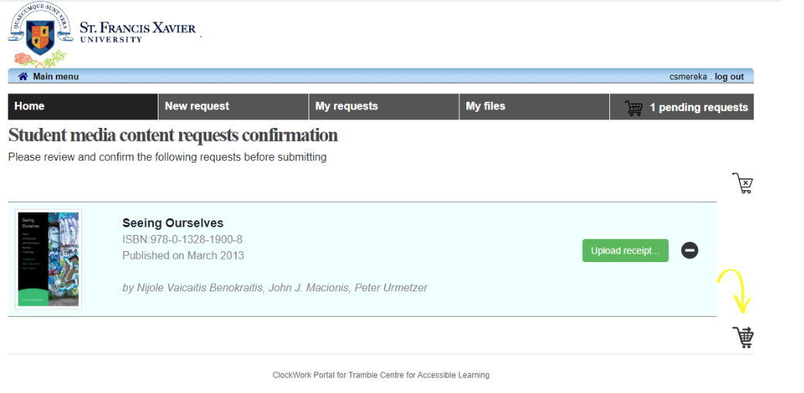

- After you upload your receipt, click the Shopping Cart again.
See image on next page.

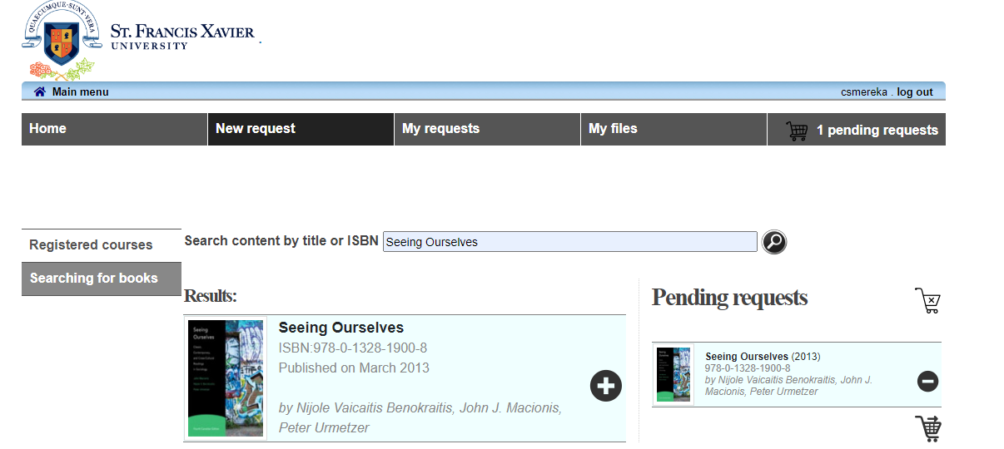
*Note – All students must show proof that they have purchased their textbooks before they will receive it in electronic format. Please email tramble.drf@stfx.ca questions you might have about receipts.

- Once your request is submitted ClockWork will direct you the Confirmation Page.

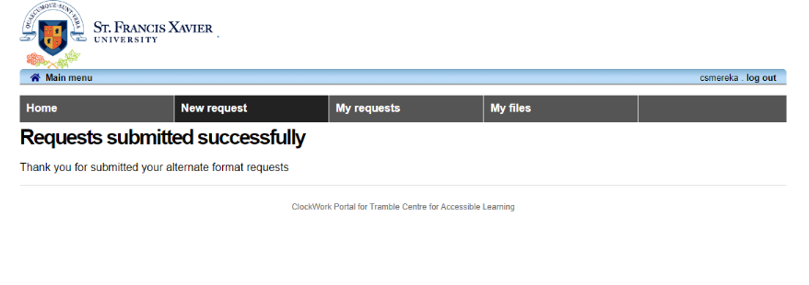

- To double-check what books you requested, you can click the View My Requests button.

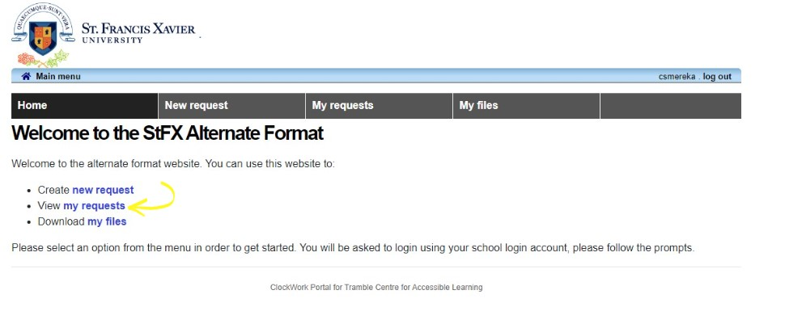14. Choose the Semester (session) you are currently in.
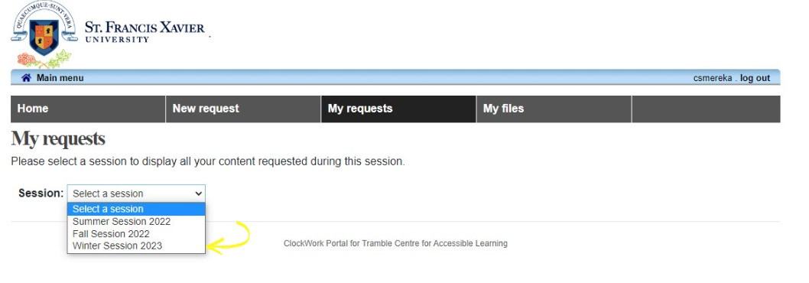
15. Here is an example of what you will see when you click View My Request.
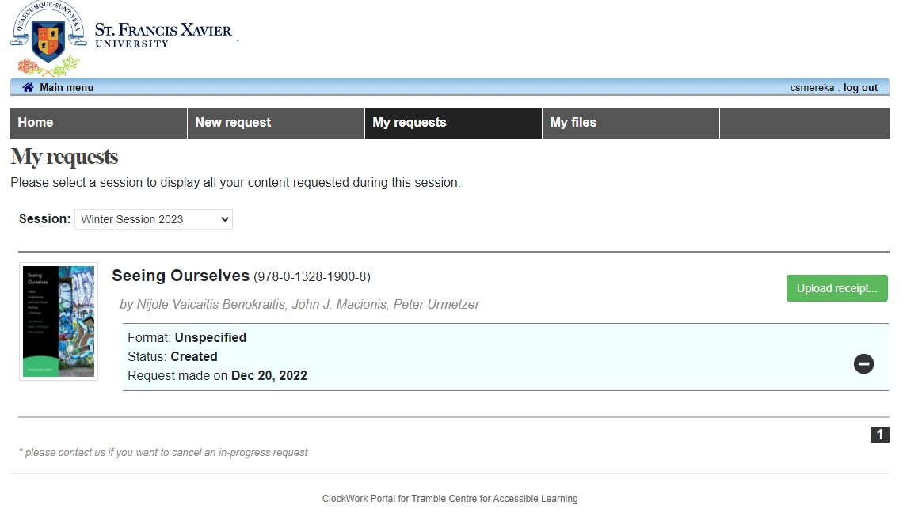

16. When your request is filled you will receive an email from ClockWork telling you to login to Download Your Textbook File.

17. To download your textbook file click the My Files button.
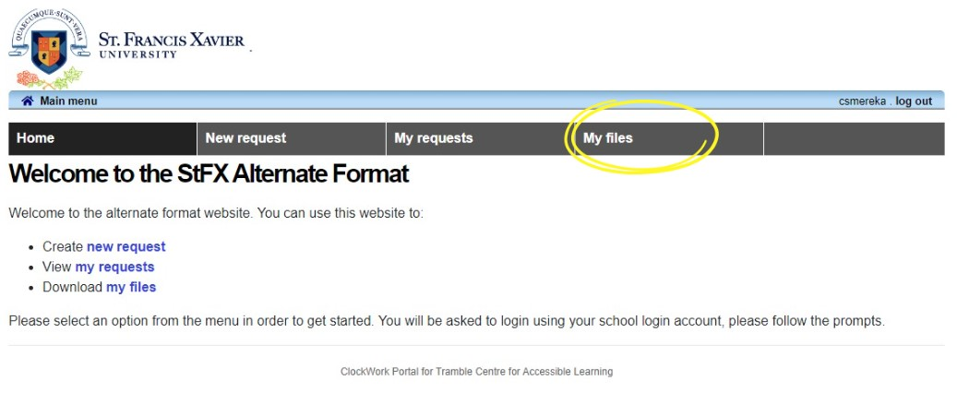
18. Click the Semester (session) you want to view.
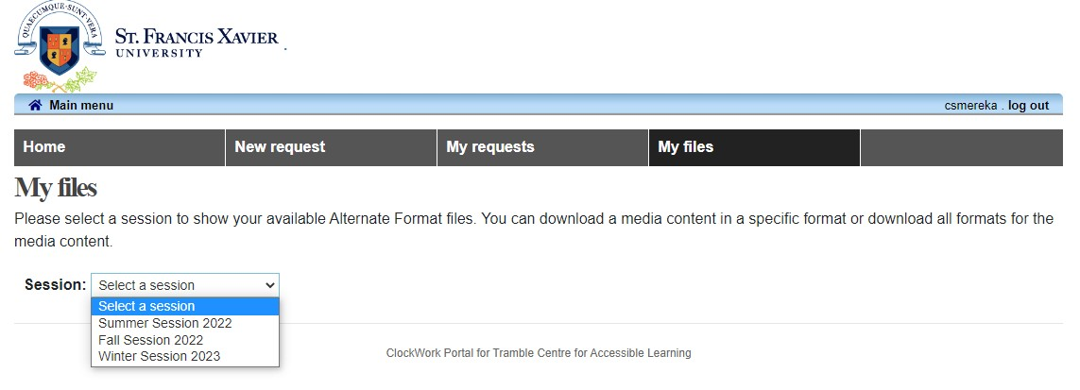
*Note – If you have any questions about Requesting Textbooks in Alternative format, please email tramble.drf@stfx.ca.

